
Vol 4 Issue 1 (Jan-March 2026)
ISSN (Online): 3006-4740
ISSN (Print): 3006-4732

The Evolving Artistic Representation of Saint Joseph: from Medieval Humor to Early Modern Patron of the Sick and Dying
Ayesha Latif
University of Management and Technology, Lahore
ayesha-latif@umt.edu.pk
Mamoona Zahid
University of Management and Technology, Lahore
mamoona.zahid@umt.edu.pk
Dr. Amna Khalid
University of Management and Technology, Lahore
amna.khalid@umt.edu.pk
Fatima Shahzad
University of Management and Technology, Lahore
fatima.shahzad@umt.edu.pk
Abstract
This paper discusses the artistic development of Saint Joseph, which is multifaceted and starts with the medieval Christian art and its canons and arrives at the point of major development of the artist as the patron saint of the sick and dying in the Early Modern period. It suggests that the visual transformation of Saint Joseph from a figure sometimes endowed with some moments of medieval humor (even if he was at times represented as a "bumbling old fool") to an idealized, dignified patriarchal protector had an intrinsic connection to the rise of his importance in religious devotion and social need. By considering changes in iconography, depictions of art, as well as the theological interpretations of depictions, the paper considers how previous, more relatable depictions set the stage for his later veneration as an intercessor for a "good death." The research especially notes the work of the Counter-Reformation and the general concern of society for illness and death as a whole that drove a reconsideration of Saint Joseph's role, whose image soon appeared everywhere in the Christian world, especially in hospitals and medical facilities, bringing comfort and an example of tranquillity. In the end, this study throws a lot of light on the dynamism of the interaction of art and theology, as well as human experience, in the formation of one of the most lasting figures in the Christian religion.
Ker Words: Saint Joseph, medieval Christian art, Early Modern period, visual transformation, holy family.

Introduction
Consider the figure of Saint Joseph in Christian art: from the late medieval period, where he was perhaps represented as a sleeping, elderly and even somewhat comical character on the periphery of the scene of the Nativity (Williams 2018; 2019), to the Counter-Reformation, to a position of tremendous dignity, represented as the vigilant and protective patriarch of the Holy Family (Hope 2011) and as a powerful intercessor for the sick and dying (López 2022, 1). Such an abrupt shift, between a character who is occasionally treated with a certain medieval humour to a calm shepherd in the moments of death, discloses a rich and contradictory development of the arts. What was this sudden visual shift that the silent Nazareth carpenter passed through, and what do these facts inform us about the shifting theological views and needs in the changing society across the centuries?
The role of Saint Joseph in the biblical account is, by contrast, very humble, he is portrayed as the husband of Mary and the foster father of Jesus on earth, but he never utters a single word in the written (canonical) text, he remains in a deep silence. Although his cult first met with a certain reticence, it acquired an eminence to a considerable degree, though slow in onset, already in the twelfth century and more marked especially since the late medieval era. (Williams 2018; López et al. 2015, 51). The traditional belief that his cult of devotion was formed only after the Council of Trent has now been directly doubted by historians who refer to pre-Trentian forms of his veneration and significance. (Williams 2018; Tokaz 2004). In fact, his popularity as an object of worship increased manifold around around 1300-1600 (Williams 2018), a time that was extensively discussed by researchers that were examining his multi-faceted cult as a father, husband and artisan (Early Modern Privacy 2021, 340). Such a development prior to Tridentine influenced him to the extent that he was even correlated with some theological figures such as Saint Peter (Richardson 2011). In this broad chronological range, this paper will identify how his artistic presentation changed towards less human, even humorous, expressions of the interpretation, which would often define the late-medieval setting and legends and plays (López et al. 2015, 51; Dzon 2005), but still expressed reverence (Williams 2018; 2019), into a more idealized, paternal figure (Hope 2011), which was also able to help others who were ill or dying in the Early Modern period (López 2022, 1). This cultural environment was very strong-minded on a holy death, in which it was hoped that the soul would be saved and not the body cured, the spiritual role of the intercessors of the dying. (Germain and Sabroe 2019, 272)
- The Medieval Joseph: Humor, Humanity, and the "Bumbling Fool"
The earliest works of art which feature Saint Joseph appear in the mosaics of the triumphal arch of saint Mary Major which belong to the 5th century. He tips the annunciation to Mary and his angelical experience as his own and wears a short tunic and a mantle of orange, the garb of an imperial courtier. See fig.1 & 2. The early Christian art provided a comparatively limited number of images of Saint Joseph whose presence was frequently subordinate to the images of Mary and Christ. By the late medieval time, however, his iconography was more intense, and in many cases was also marked by the attributes that in modern view may have seemed rather secular.
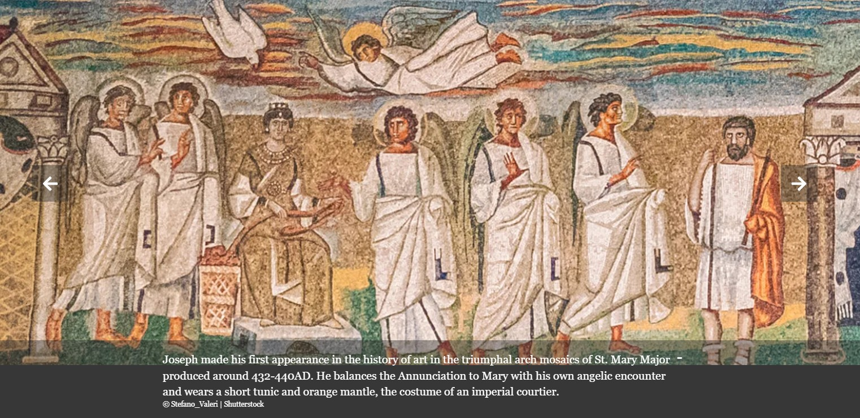
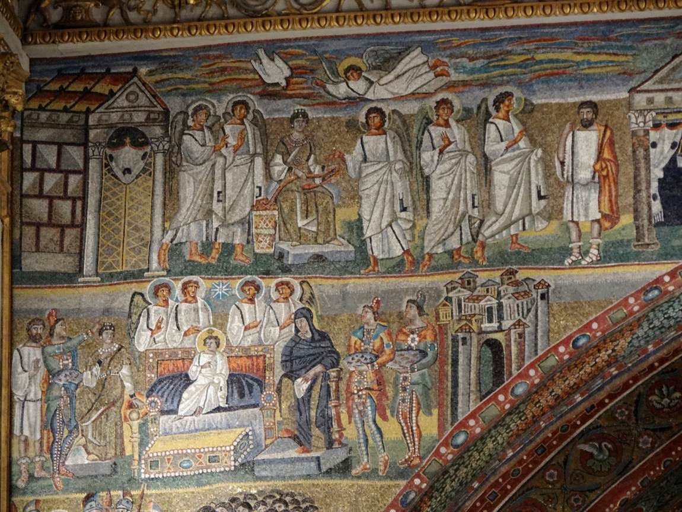
Figure 1: Mosaic Decoration in the Basilica of St. Mary Major, Rome 432-40 AD
  - Early Depictions and Iconography
To affirm the eternal virginity of Mary, Saint Joseph often artworks of early Christian art depict him as an aged man; this is a planned aspect of this art style (Sowley 2012, 440; Cruz 2019, 262). The nativity picture in Sinai art collection of 7th century portrays Joseph as an older man standing alone of the Virgin and Child, fully fulfilling his role of mere intact Virginity protector to Mary (Serebrennikov 2021, 931). (See fig. 3). This visual placement was often placed at the edges of the composition and played the role of protecting the virginity of Mary and the more subordinate role that the male figure in the Nativity scene had (Friedman 2023, 215). Equally, iconography in ivory relief depicting appealing scenes also has a nursing animal, Jesus first bath and angel hugging a shepherd but joseph mulling alone. (see fig. 4). Such description helped him to earn the status of a loyal protector instead of a biological parent.
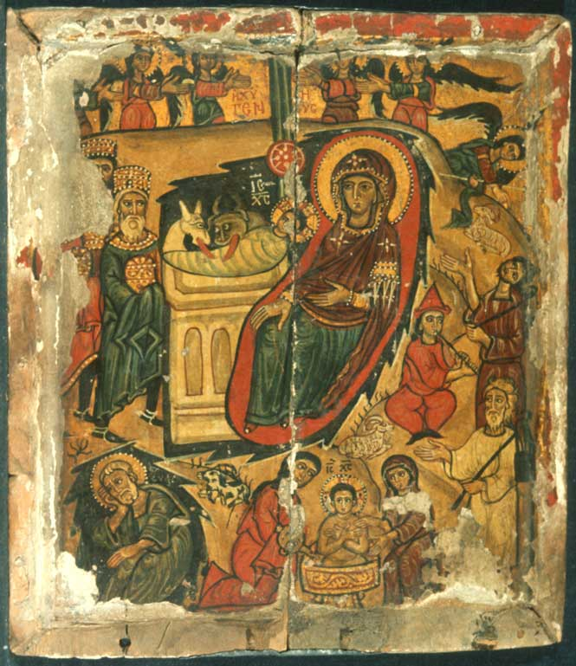  Figure 2: Nativity – The Sinai Icon Collection 7th century | 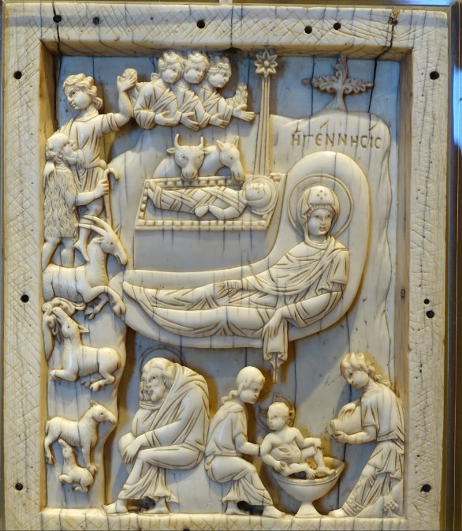  Figure 3: Ivory reliefs carved in Constantinople in the 11th century in Vatican Museum.
  - The Role of Humor and Satire
One of the most prominent features of the artistic traditions in the Middle Ages was the application of humour and satire to the religious subjects and Saint Joseph was not an exception (Williams 2018; 2019). This did not mean that this was necessarily opposing to worship but it was instead in line with modern popular culture and might even enhance the spirituality of the faithful (Williams 2018). Portraits of Saint Joseph with his weary and drowsy and menial, rather anachronic composition were frequent. As an example, we can often see him asleep in Nativity, or involved in household tasks when Mary and the Christ Child are the subjects of interest (Coursey 2019, 54). These may be the way that Joseph warmed up the water to bathe the baby, making his feet warm near a fire, or simply going back to get water to the Holy Family on their Flight out of Egypt (Payan 1997, 3). (see fig.4,5 & 6)
These images could also be seen in the plays of the medieval times, including the York Corpus Christi plays, where Joseph could be labeled as "grumbling" or as an awkward fourth wheel (Coursey 2019, 54). According to Anne L. Williams, this kind of humor, which, at times, includes him as an old fool, went hand in hand with his earlier admiration, particularly between the 14th and the early 16th centuries (Williams 2018). t played a complicated role, and could be relatable and well-liked, and even slightly critical of societal expectations, without diminishing his final holiness (A. Williams 2020; A. L. Williams 2018). These humorous aspects were especially common in the courtly art of the early 15th century, but they were the minority of all the possible representations (Payan 1997, 3).

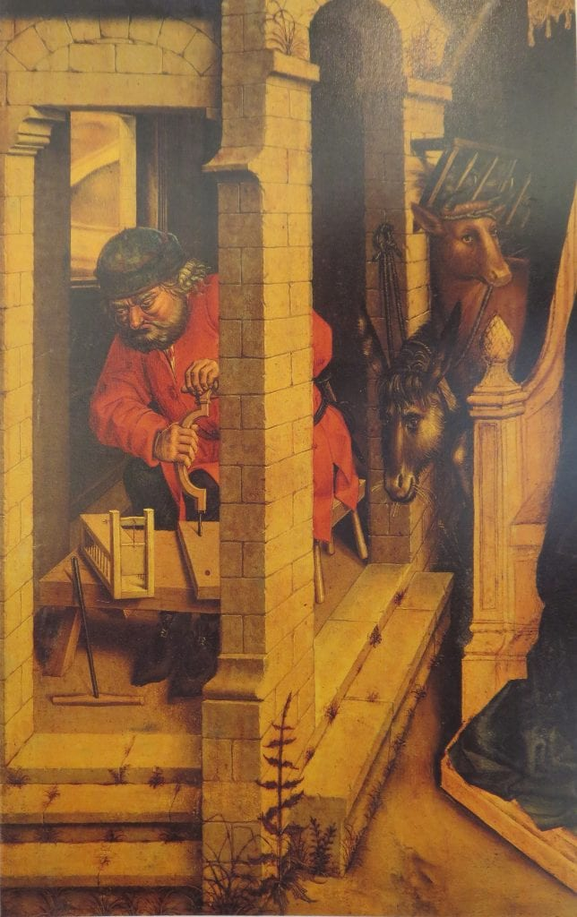  Figure 4: Master of the Legend of Saint Barbara (active in Brussels, 1470–1500), Adoration of the Magi, detail of central panel of a triptych, ca. 1480, oil on oak, 90.7 x 96.7 cm. Rome, Galleria Colonna, inv. 234 | 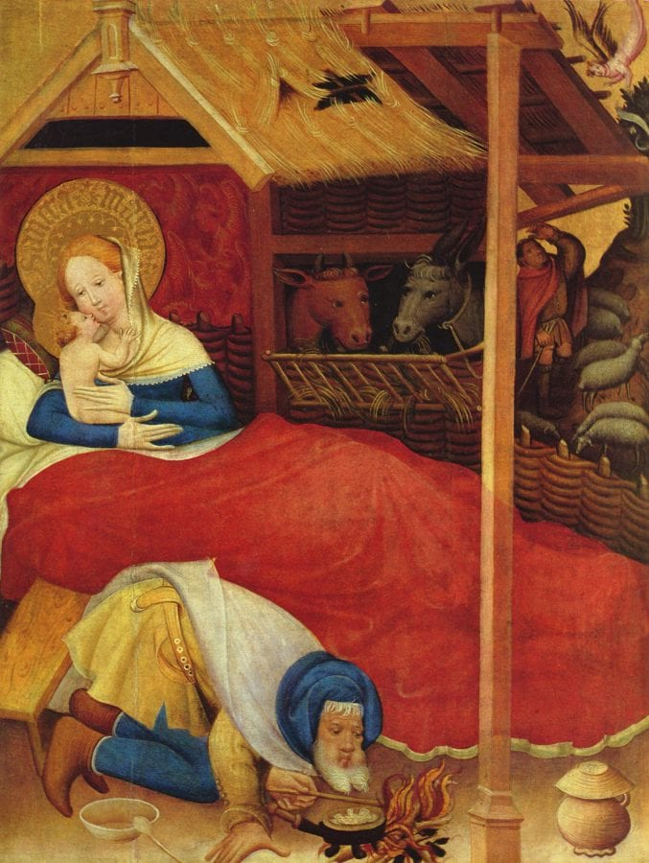  Figure 5: Conrad von Soest, Nativity, detail of the Wildunger Altar, 1403, tempera on wood, 188 x 152 cm. Bad Wildungen, Germany | 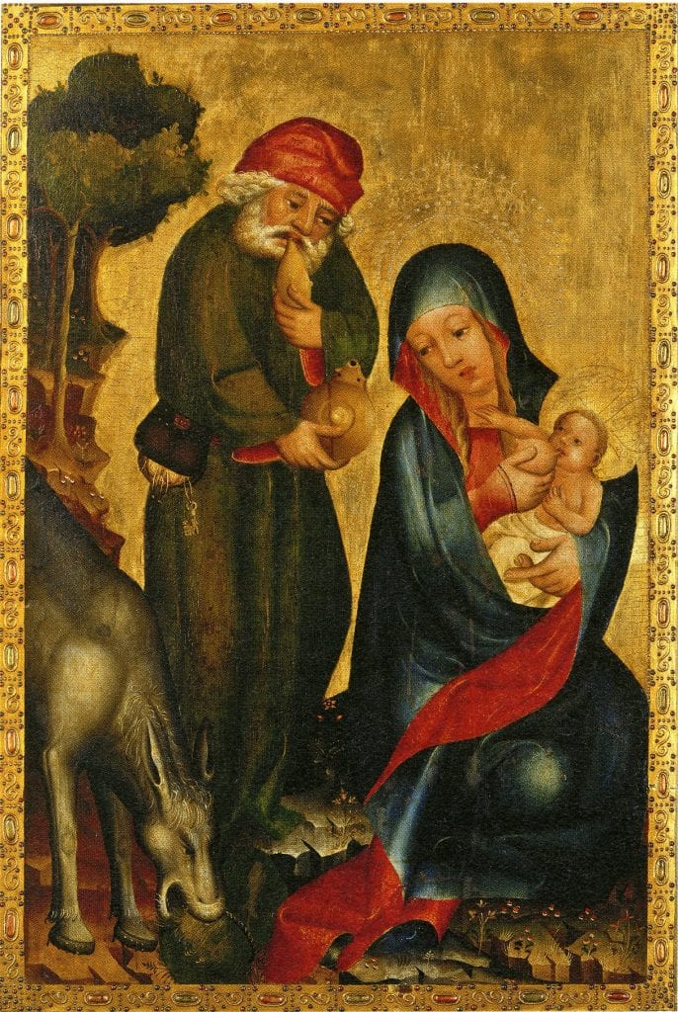  Figure 6: Meister Bertram von Minden, Rest on the Flight into Egypt, detail of the Petri-Altar (Grabow Altar), 1379–83, tempera on oak, 266 x 726 cm (overall). Hamburg.
  - Contextualizing Medieval Art:
These representations can only be viewed in this context, in terms of their relationship to the artistic styles and patronage of the High and Late Middle Ages. Art was didactic, devotional and decorative often mirroring the daily lives and humorous base of life among the people. Such humanized, even humorous, images apparently appealed to the faithful, and the effectiveness of the popularity of Saint Joseph, which has increased exponentially between ca. 1300 and 1600, opines Williams (2018), can be interpreted as those portraits being more accessible, as well as realer.
- Renaissance and Baroque Transformation: Towards Idealization and Paternal Dignity
The shift of the modern-day era to the medieval period was a complete change in artistic and theology understanding of Saint Joseph. His image shifted towards the edge of things to the high status of centrality and ideal dignity.
  - The Council of Trent and Theological Reaffirmation
The Counter-Reformation, the trigger of which was the Council of Trent (1545-1563), contributed to the shaping of the emphasis of the importance of Saint. Although the Council promulgated general decrees which recommended the application of good and pious religious images, it stimulated a re-evaluation of the role of Joseph implicitly and more dignified and idealized representations that could lead to devotion (Ditchfield 2023; Waterhouse 1972). This period was characterized by the intentional attempt to remove any perceived form of religious art as something sacrilege, and to strengthen Catholicism (Harpster 2023; Carrabine 2017). Therefore, Saint Joseph has come to the figure of a universally represented image; the chaste leader of the Holy Family, a protective patron, and a caring father, and is often called padre nourricier (Black 2006). (see fig.7). In this case Joseph occupies the same visual plane with Virgin. In addition to that, Joseph is neither elderly nor a young man, but a suitable match to Mary. This position establishes him as an exemplary chaste, obedient and fatherly figure, who was encouraged by the post-Tridentine Church (Wilson 2007).
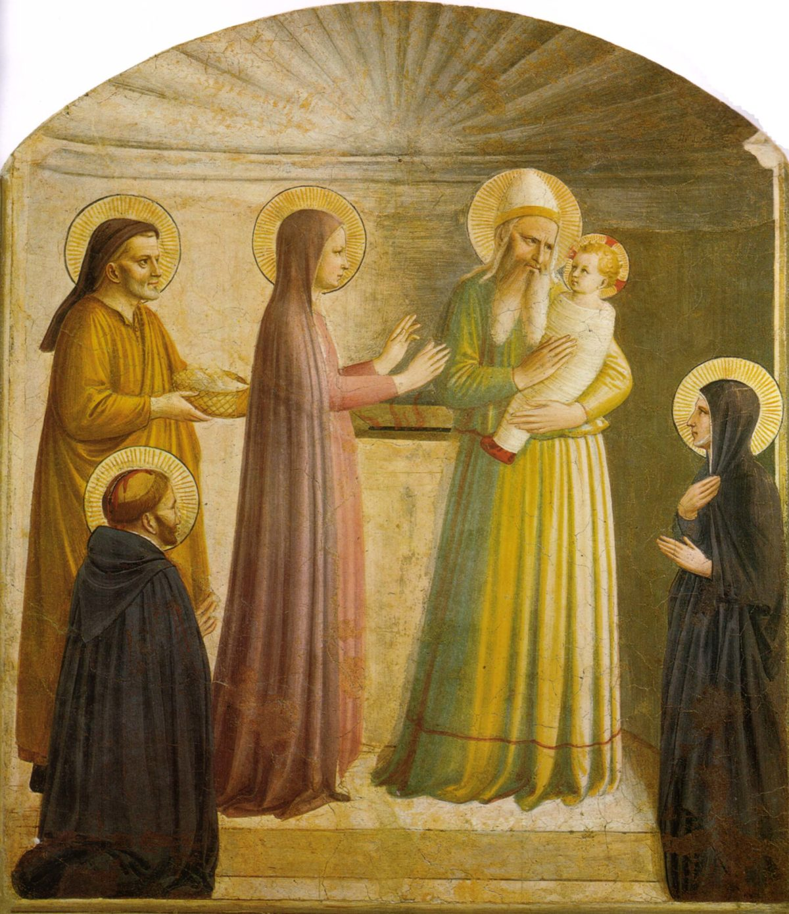
Figure 7: The Presentation of Jesus in the Temple – Fra Angelico (ca 1540)

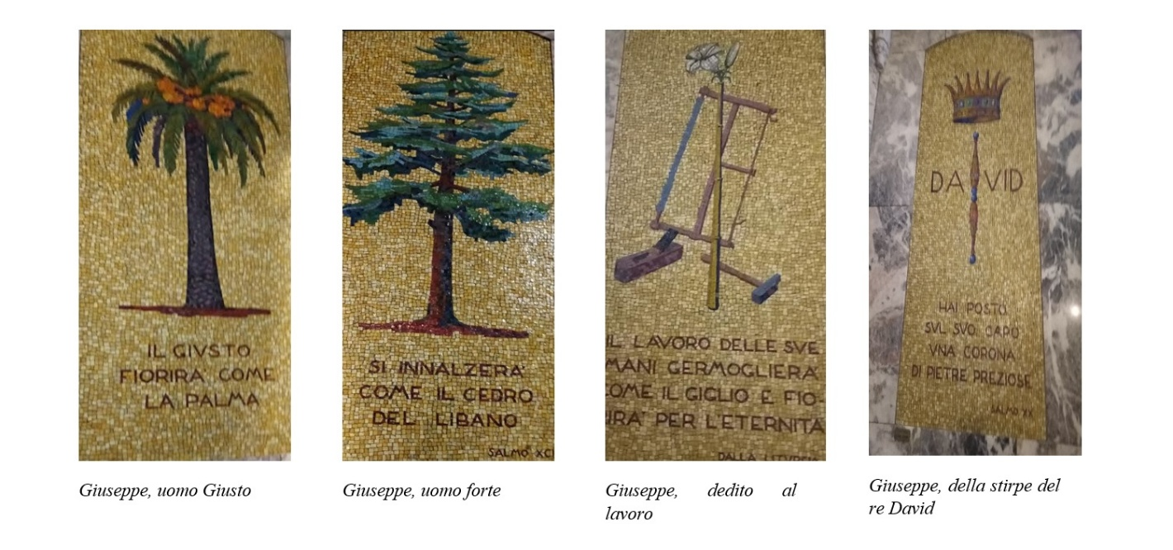
Figure 8: Mosaics with symbols of the Davidic dynasty and the life of St. Joseph, The sanctuary of San Camillo.
  - Iconographic Attributes of Idealization
Artists also codified a canon of iconographic qualities in a quest to explain his lofty virtues. The lily, which is synonymous with purity and chastity, has become a near-universal motif in his depictions (Foster 1979; Rotter 2021) (see fig. 8) The tools of the carpenter, a square, saw or axe, have become symbols of mindless work and now they are a symbol of noble work and a role of a provider by the worker thus supporting his hard labor and his humble godliness (Hope 2011). Most importantly, the recurrence of the depiction of Saint Joseph holding the infant Jesus in his arms demonstrated his male tenderness and nurturing nature (Simons 2021). (see fig. 9 & 10). All these traits create an emphasis on his holiness, his strength, and his central, proactive position in the Holy Family, thus drifting away in comparison to his previous portrayals as rather passive or humorous.
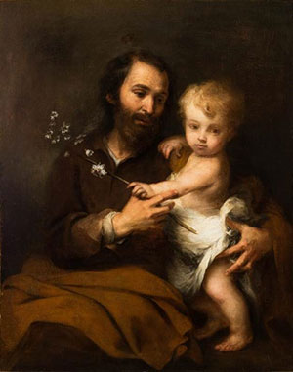  Figure 9: St Joseph and the Child Christ – Bartolome Esteban Murillo (ca 1670-75) | 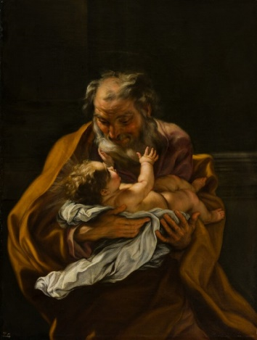  Figure 10: Saint Joseph Embracing the Infant Christ c. 1670-75 Giovanni Battista Gaulli, called Il Baciccio (Italian, 1639-1709)
  - Artistic Styles and Masterpieces
In the Renaissance and Baroque, a new idealized image of Saintishin boringon was developed and used by the artists, and now serves as a staple of the artworks of these periods. The masters of the High Renaissance, including Raphael and El Greco invested their depictions with the dignity of classics and theological depth. Later Baroque painting, such as Guido Reneri and Francisco de Zurbaran exaggerated his emotional impact, often portraying him in the ecstatic contemplation of his works or in close communion with Christ, and thus conveyed a sheer feeling of holiness and paternalism. Such changes in art, the use of dramatic light, vivid colour, and expressiveness, which conveys that he is an elevated person, worked to deeply inculcate his significance in popular devotion. These changes are greatly captured by the scholarly work of Janet Hope who has mainly documented the changes that have occurred since the medieval times up to the early modern era (Hope 2011).
- Saint Joseph as Patron of the Sick and Dying: An Early Modern Development
As his artistic idealisation was evolving, in the Early Modern period the Saint Joseph became a potent patron saint of the sick and the dying, which in turn had an immense impact on his iconography and popular abacus. The role of Saint Joseph as an intercessor of the ill and dying expanded exponentially between the 16th and the 18th century (López 2022, 1). This movement was deeply entrenched in the popular obsession with a good death (ars moriendi) in a time of plague epidemics and great death. Joseph was worshipped as a model of a peaceful death, which supposedly occurred peacefully in front of Jesus and Mary, which made him an ideal supporter of people who were going to die (Germain and Sabroe 2019, 272; López 2022, 1).(see fig. 11 & 12) His intervention was also not aimed at some miracle cures, but rather spiritual solace, peaceful death and protection against unexpected and unproven death (Early Modern Privacy 2021, 383; López 2022, 1). This type of patronage catapulted him to the top of the list of desirable individuals in the society that was living in constant fear of illness and mortality, and placed him in the role of a caring shepherd to the so-called agonizantes (those in agony) (López 2022, 1).
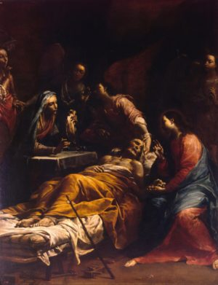  Figure 11, The Death of St. Joseph – Giuseppe Maria Crespi (ca 1712),  example for all who wish to succumb to the loving embrace of Our Lord  His sole focus is on the face of the young Christ who offers him blessing and passage.  Joseph’s peaceful passage after a life of devotion | 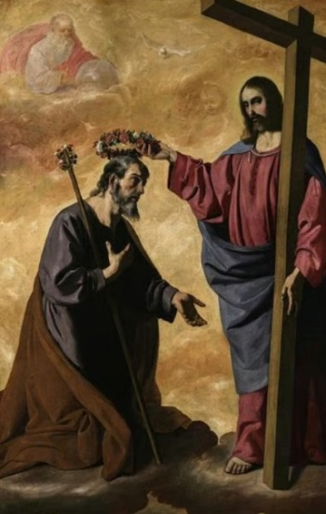  Figure 12, "Christ Crowning Saint Joseph" Francisco de Zurbarán (1598–1664) is housed in the Museo de Bellas Artes in Seville, Spain
  - Artistic Depictions in Healthcare Spaces
This newfound patronage had a big role to play in the artistic portrayal of Saint Joseph especially in health and charity institutions. Certain iconographic types became very common, i.e. the death of the saint Joseph, which depicts him dying peacefully in bed, with Christ and Mary appearing nearby (López 2022, 1). These pictures were not just devotional, but did have a practical purpose, to decorate hospitals and hospices and even family chapels related to confraternities of helping the sick and granting a peaceful death (López 2022, 1). The spread of his artistic image in these locations brought solace and promise to the sick and dying, and the manifestation of his intercessory power, and gave them an image of comfort (see fig. 13). In his role, Joseph eventually replaced elder and conservative patron saints related to the ill becoming a major spiritual source to depend upon in the face of mortality (López 2022, 1).
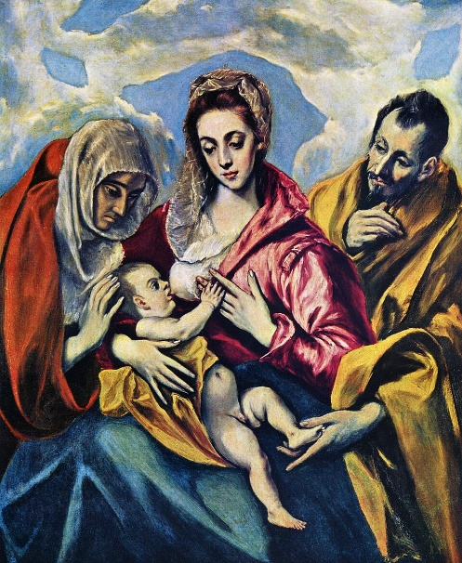  Figure 13, El Greco, Holy Family, c.1595, Hospital de Tavera, Toledo. | 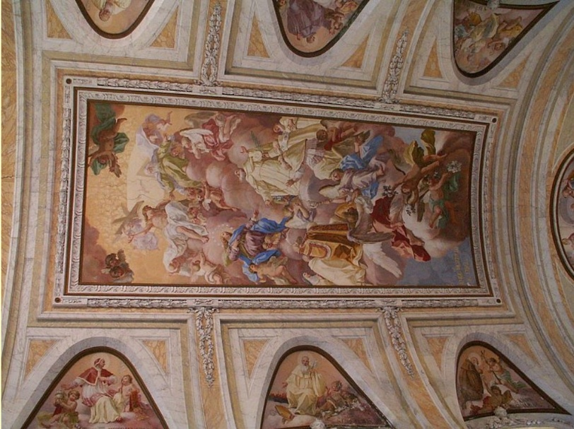  Figure 14, The Hermitage of Camaldoli, Camaldoli Hospital (Naples - Villa Camaldoli), Via Antonio Cinque, Naples, Italy. This is a modern, private healthcare facility (Casa di Cura) located on the Camaldoli Hill in Naples.
  - Connecting the Evolution
The above idealisation and enhanced exaltation of Saint Joseph in the Renaissance and Counter-Reformation were responsible directly to his appropriateness in this new role. His humorous to stately moral worthiness as a patriarch, when man was giving aid to the dying, gave more credence and more comfort to his indulgence than to his richness, than to his ability to acquire or to lose riches. Such stress on his male virtues and his unbending confidence in his faith put him in a position of trusted intercession, whose calm death brought hope and confidence at a time of deep anxiety about death. Therefore, the development of art was more than a matter of beauty in him, but a highly practical matter that determined him a very important spiritual shepherd in the Early Modern world.

Problem Statement/Gap
Although there is an existing scholarship on the early, occasionally humorous, images of Saint Joseph, his subsequent idealization, a complete investigation into how these divergent artistic traditions interrelate with each other especially in the development of him as a patron of the sick and dying is one of the critical gaps in literature. Although the transformation of warm-blooded and familiar mediaeval characters to the noble figure of the Counter-Reformation, and the progress of his patronage of the sick and dying in history, the immediate connexion between his former artistic geniality and his death transcendence as a mediator of a good death has not been clearly expressed. In this paper, it is suggested that it was precisely the details of his previous humanized image, such as content of humour and domesticity, which provided a basis and paradoxically gave rise to his subsequent idealized one and particular patronizing. Some of the earliest works of the Middle Ages were marginal, as were some works of later mediaeval times, including the so-called Dream of St. Joseph on Anglo-Saxon crosses (Cassidy 1996). Nevertheless, he frequently remained in the background of the Nativity scenes and in some cases, he was substituted by other figures to focus on the theological focus of the image (Beaud 2012, 146). By the 14th century, he was more integrated but with various interpretations alternating between a learned protector, the nourisher of the Lord, Domini (giver), and a more comical, clumsy and unconscious old fool (Williams 2019).
Significance of the Study
With help of the gap in analysing mediaeval humour into the Counter-Reformation theology and his patronizing activities of dying, this study provides a distinctive look at the consistent, though complicated, path of artistic and devotional growth of Saint Joseph.
Literature Review
The artistic image of Saint Joseph, who was originally a minor figure in Christian theology, has been tested and changed dramatically, drawing the interest of art historians and theologians. The iconography of him has always been noted, however, to be the subject of an evolving tradition of humility and sometimes even humorous aspects in the early mediaeval image of him, to a more dignified and idealised version in the Renaissance, up to the Early Modern period. (Hope 2011).
The image of Saint Joseph in the mediaeval times was a subject of a debate in earlier studies. The simplistic division of his mediaeval pictorials into either comical or derogatory is disputed by Anne L. Williams, who argues in the former article, Satirising the Sacred: Humour in Saint Joseph Veneration and Early Modern Art, (Williams 2018) and in the latter, Joseph Hosen Devotion and Humour (Williams 2019) how such issues are intertwined in his work. According to Williams, humour, which was found in the fourteenth through the early sixteenth centuries in art, did not necessarily reduce veneration but instead was a reflection of the popular culture, and even a fortification of the sacred (A. L. Williams 2018; A. Williams 2020) She claims that these previous depictions usually portray Joseph as weary, old or performing some menial task, fulfilled a multifaceted purpose, complete interpretations that once polarised his image (Williams 2018). The presented body of work highlights the importance of looking at the artistic humour of the Middle Ages in cultural and theological specifics instead of interpreting it through the modern context, which could entangle the concepts of humour and disrespect (Williams 2019). Coupled with this, Carol M. Richardson looks at how the role of Saint Joseph has changed towards the fifteenth century starting with his mediaeval imagery and the theological debates that justified his significance, suggesting that even preceding the full onslaught of the Counter-Reformation, signposts of his high rank were present (Richardson 2011). Another review of the work by Carolyn C. Wilson by John Tokaz further helps to redress the idea that the cult of Saint Joseph was a non-existent and marginalised cult in the renaissance period (Tokaz 2004). This overall increase and role of the cult of saints in Latin Christianity gives further background to the cult of Saint Joseph (Bartlett 2013; Brown 2014; Weinstein and Bell 1986).
With the passing to the Renaissance and Baroque periods the significance of Saint Joseph in art was vastly increased, as per the general theological reorientation. In her article by Janet Hope titled Transformations of the image of St Joseph in early modern art, she highlights the mediaeval period up to the end of the council of Trent as the most active period of the changes (Hope 2011). Although the council of Trent (1545-1563) was publishing general decrees on the religious images, it was an important tool in influencing the line of post-Reformation Catholic art. It fostered an unambiguously theologically well imagery that would evoke piety and veneration and implicitly urged the artists not to create potentially irreverent images (Waterhouse 1972; Ditch field 2023; Carrabine 2017). Higher critics like Grace Harpster have outlined how ecclesiastical visitors after Trent used the basis of decorum in images on the basis of functionality, which influenced the manner in which religious icons were depicted (Harpster 2023). The English scholarship in the area of the Council influence on saints and mystics, or the reformation of art during the Late Renaissance is also a field of study (Noyes 2020; Rowe 2013). During this time, Saint Joseph was likewise re-represented with elements that further amplified his virtues (e.g., the lily of purity) and more of a human appearance of spirituality especially in his connexion with the Infant Jesus.
The article by Patricia Simons about the Emotional Efficacy of the Early Christ Child Sculptures (Simons 2021) offers an understanding of the process of the creation of emotional connection in religious art and this feeling would be naturally transferred to Saint Joseph the one who was depicted in his moments of interaction with the Child. This idealization has been further developed by Charlene Villasenor black (Black 2006) in her work, Creating the Cult of St. Joseph: Art and Gender in the Spanish Empire in which she examines the gendered discourse present in such themes as Mothering Fathers and Happy Families showing how artfully created constructions placed him as the protective and nurturing patriarchal figure in the military service (Wilson 2007). J. The edited book by Chorpenning, Joseph of Nazareth through the Centuries, also includes in-depth information regarding his changing cult as a father, husband, artisan, and contemplative (Early Modern Privacy 2021, 383). At the same time as this idealization, the essential development of Saint Joseph as a patron saint of the sick and dying took place in the Early Modern Age. Historical accounts, which feature works like the book by Joseph of Nazareth through the Centuries (Early Modern Privacy 2021, 383) are unanimous in pointing out that Saint Joseph gained great favour among the ill and dying. It is commonly associated with the idea of a good death, and Joseph was an ideal of peaceful death and a charitable role model to caretakers (Wilson 2007; Early Modern Privacy 2021, 383). His artistic depiction stretched far and wide in hospitals and medical facilities to be of comfort and representation of calmness.
This evolution had seen Saint Joseph slowly competing with more traditional granter of saints to the sick and dying, his likeness becoming a comfort and source of intercession in the sight of rampant illness and the fears about a good death (Wilson 2007). In general, academic sources depict the processes of the acquisition of certain patronage functions by saints as their cults evolved, according to the spiritual and material needs of believers in specific historical contexts (Bartlett 2013; Brown 2014; Weinstein and Bell 1986). To conclude, much of the English scholarship has been done to consider different aspects of the artistic representation of Saint Joseph, such as the subtlety of humour in mediaeval society (Williams 2019; 2018) and his exaltation by the fifteenth century (Richardson 2011) or the effects of the Counter-Reformation on making him a perfect figure of churchmen (Black 2006; Hope 2011) and how his cult has developed in a comprehensive manner (Early Modern Privacy 2021).
Conclusion
The evolution of the images of Saint Joseph was a deep artistic process, which was discussed in this paper and explained how his portrayal had changed over the centuries since the mediaeval times, when he was frequently depicted with a comic touch, to idealised patricianism of the Renaissance and baroque eras. This would play a very defiant role in ensuring his introduction as one of the primary patrons of the sick and the dying in the Early Modern art. Being described as either funny or even humorous at first yet still managing to enhance the popular piety (Williams 2018; 2019) yet his subsequent idealised statuses of the holy leader of the Holy Family (Hope 2011), the visual narrative of Saint Joseph has always traced back to reflect the theological relevance. This image transformation led to his eventual emergence as the patron of a good death (Germain and Sabroe 2019, 272; López 2022, 1), which fulfilled certain spiritual and social requirements of those times.
The analysis of the artistic changes of Saint Joseph provides much important information about the evolving dynamics of the interaction of art and theology and the social surrounding of the Christian piety. It emphasises the fact that religious iconography is not a static phenomenon, it is a dynamic process which is influenced by the altering cultural values, religious fear, and reworking of doctrines. The way Joseph was transformed, in his lifetime, into a lowly, seemingly stereotypical-looking character until adopting a divine role as a petitioner of deaths of believers, is an example of how religious art can change the nature and adaptable quality of faith and reverence over time.
Directions for further study
Future studies might investigate the spatial differences in patronage of the sick and dying by Saint Joseph, how the various local traditions and schools of art focused on particular features of this work. The specific attraction and iconographic development of Saint Joseph as a patron saint of the sick, in comparison with other such saints, including Saint Sebastian or Saint Roch, may be further clarified by a comparative study of these other patron saints of the sick. Still, more detailed analysis of the specific artistic devices employed to present his part in the healing process and in a peaceful death, particularly in those works not so often considered, of hospitals or confraternities, may enhance our understanding of this interesting devotional effect.
References
Bartlett, Robert H. 2013. Why Can the Dead Do Such Great Things? Princeton University Press eBooks. Princeton University Press. https://doi.org/10.1515/9781400848782.
Beaud, Mathieu. 2012. “Iconography and Monumental Art in ‘Feodal Space’ from the 10th to the 12th Century: The Depiction of the Three Kings and Its Spread.” HAL (Le Centre Pour La Communication Scientifique Directe), December. https://theses.hal.science/tel-00841677.
Black, Charlene Villaseñor. 2006. Creating the Cult of St. Joseph: Art and Gender in the Spanish Empire. Princeton University Press eBooks. Princeton University Press. https://doi.org/10.37862/aaeportal.00281.
Brown, Peter. 2014. The Cult of the Saints: Its Rise and Function in Latin Christianity, Enlarged Edition. https://www.amazon.com/Cult-Saints-Function-Christianity-Enlarged/dp/022617526X.
Carrabine, Eamonn. 2017. “Punishment in the Frame: Rethinking the History and Sociology of Art.” The Sociological Review 66 (3): 559. https://doi.org/10.1177/0038026117705031.
Cassidy, Brendan. 1996. “The Dream of St. Joseph on the Anglo-Saxon Cross from Rothbury.” Gesta 35 (2): 149. https://doi.org/10.2307/767179.
Coursey, Sheila. 2019. “Crime, Community, and Audience Engagement in Late Medieval and Early Modern Theatre.” Deep Blue (University of Michigan), January. https://hdl.handle.net/2027.42/151522.
Cruz, Roser López. 2019. “‘Virgen Bella, Nuestras Paces Os Encargo’: «Las Paces de Los Reyes y Judía de Toledo» or the Political Bet on a Miraculous Image.” Anuario Lope de Vega 25 (January):257. https://doi.org/10.5565/rev/anuariolopedevega.304.
Ditchfield, Simon. 2023. “The Cambridge Companion to the Council of Trent, Edited by Nelson H. Minnich.” Journal of Jesuit Studies 11 (1): 157. https://doi.org/10.1163/22141332-11010007-01.
Dzon, Mary. 2005. “Joseph and the Amazing Christ-Child of Late-Medieval Legend.” In , 135. https://doi.org/10.1515/9783110895445.135.
Early Modern Privacy. 2021. BRILL eBooks. Brill. https://doi.org/10.1163/9789004153073.
Foster, Marjory Bolger. 1979. The Iconography of St. Joseph in Netherlandish Art, 1400-1550.
Friedman, John Block. 2023. “Word into Image: Apocryphal Infancy Gospel Motifs on Antoni Gaudí’s Sagrada Familía Nativity Façade.” Digital Philology 12 (2): 215. https://doi.org/10.1353/dph.2023.a911845.
Germain, Lewis, and Ian Sabroe. 2019. “The Care of Dying People in 16th- and 17th-Century England.” Death Studies 44 (5): 270. https://doi.org/10.1080/07481187.2018.1541941.
Harpster, Grace. 2023. “Evaluating the Altarpiece: Image Decorum in Post-Tridentine Apostolic Visitations.” Religions 14 (5): 615. https://doi.org/10.3390/rel14050615.
Hope, Janet. 2011. “Transformations of the Image of St Joseph in Early Modern Art - Volume 1: Text; Volume 2: Illustrations.” BCU Open Access Repository (Birmingham City University). Birmingham City University.
López, Irene Madroñal. 2022. “El Nuevo Patronazgo de San José: Reflejo Artístico y Espiritual de La Enfermedad y La Muerte En La Edad Moderna.” Temperamentvm 18 (September). https://doi.org/10.58807/tmptvm20225129.
López, Mariana, Frank Napolitano, Elizabeth Schafer, Alison Findlay, Ramona Wray, Yasmin Arshad, Helen Hackett, Emma Whipday, and Rebecca McCutcheon. 2015. Early Theatre 18 (2). https://doi.org/10.12745/et.18.2.
Noyes, Ruth Sargent. 2020. “Art and Reform in the Late Renaissance: After Trent, Edited by Jesse Locker.” Journal of Jesuit Studies 7 (3): 507. https://doi.org/10.1163/22141332-00703008-11.
Payan, Paul. 1997. “Pour Retrouver Un Père... La Promotion Du Culte de Saint Joseph Au Temps de Gerson.” HAL (Le Centre Pour La Communication Scientifique Directe), January. https://hal.science/hal-03305103.
Richardson, Carol M. 2011. “St Joseph, St Peter, Jean Gerson and the Guelphs.” Renaissance Studies 26 (2): 243. https://doi.org/10.1111/j.1477-4658.2011.00724.x.
Rotter, Lucyna. 2021. “Kult Świętych w Regułach Zakonnych Na Przykładzie Zgromadzenia Sióstr Felicjanek.” Folia Historica Cracoviensia 13 (June):109. https://doi.org/10.15633/fhc.1465.
Rowe, Erin Kathleen. 2013. “Saints and Mystics: After Trent.” Oxford Bibliographies Online Datasets. https://doi.org/10.1093/obo/9780195399301-0100.
Serebrennikov, Nina Eugenia. 2021.: “: Pieter Bruegel the Elder: Religious Art for the Urban Community.” Renaissance Quarterly 74 (3): 931. https://doi.org/10.1017/rqx.2021.112.
Simons, Patricia. 2021. “‘Kiss the Feet of the Infant Jesus’: The Emotional Efficacy of Early Christ Child Sculptures in Europe and Beyond.” In , 247. https://doi.org/10.1163/9789004464681_008.
Sowley, Katherine Ilsley. 2012. “The Lady and the Unicorn Tapestries: Feminine Figures at the Service of the Masculine Image.” HAL (Le Centre Pour La Communication Scientifique Directe), December. https://theses.hal.science/tel-00915155.
Tokaz, John. 2004. “St. Joseph in Italian Renaissance Society and Art: New Directions and Interpretations (Review).” The Catholic Historical Review 90 (4): 781. https://doi.org/10.1353/cat.2005.0079.
Waterhouse, Ellis. 1972. “Some Painters and the Counter-Reformation before 1600.” Transactions of the Royal Historical Society 22 (December):103. https://doi.org/10.2307/3678831.
Weinstein, Donald, and Rudolph M. Bell. 1986. Saints and Society. https://doi.org/10.7208/chicago/9780226890579.001.0001.
Williams, Anne. 2020. Satire, Veneration, and St. Joseph in Art, c. 1300-1550. https://doi.org/10.5117/9789462983748.
Williams, Anne L. 2018. “Satirizing the Sacred: Humor in Saint Joseph’s Veneration and Early Modern Art.” Journal of Historians of Netherlandish Art 10 (1). https://doi.org/10.5092/jhna.2018.10.1.3.
2019. “Joseph’s Hosen, Devotion, and Humor: The ‘Domestic’ Saint and the Earliest Material Evidence of His Cult.” https://doi.org/10.1017/9789048534111.002.
Wilson, Carolyn C. 2007. “Creating the Cult of St. Joseph: Art and Gender in the Spanish Empire (Review).” The Catholic Historical Review 93 (3): 652. https://doi.org/10.1353/cat.2007.0325.
Weblinks for Images

Saint Joseph Embracing the Infant Christ (Norton Simon Museum)
Hermitage reference page — The Death of St. Joseph (Crespi)
https://www.camilliani.org/en/san-giuseppe-con-i-camilliani-a-milano/
https://aleteia.org/2021/02/26/st-joseph-in-art-an-enigmatic-and-elusive-figure/
https://aleteia.org/2021/03/12/st-joseph-in-art-the-silent-knight/
https://www.goodcatholic.com/truths-about-st-joseph/
https://smarthistory.org/cusco-school-artist-saint-joseph-and-the-christ-child/
https://yearofstjoseph.org/devotions/sacred-artwork/
https://www.artera.ae/artworks/703d560b-dcba-4381-81cf-6e0d4575e884
https://naplesldm.com/Hermitage/target5.php

